REGex Software Services

Java Full Stack Development Program

Registration I'd: IIPRSS1404

Name: Shanmukh Subhash Kumbhar

Subject: Assignment: **MySQL Assignment - 2**

**MySQL Assignment - 2**

|  |  |  |  |
| --- | --- | --- | --- |
| **EMPLOYEE** | | | |
| **ID** | **NAME** | **SALARY** | **DNO** |
| **101** | **Jones** | **5500** | **10** |
| **102** | **Smith** | **4500** | **10** |
| **103** | **Wills** | **6500** | **30** |
| **104** | **John** | **3500** | **20** |
| **105** | **NULL** | **4200** | **30** |

**Solve the fallowing queries;**

1. **Display all employee;**

1. **Display only Name and Salary columns details**

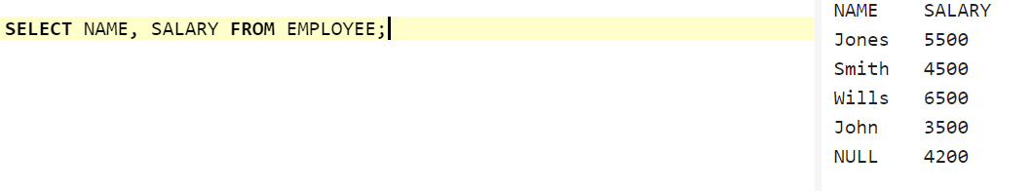

1. **Display all employees belong to dno 30.**



1. **Display all employee whose salary is less than 5000**

1. **Display all employee whose salary is greater than 5000**
2. **Display all employees except dno 10;**

1. **Display only employees whose id are 101, 103 and 105;**

1. **Display all employees except whose id’s are 101, 103 and 105**



1. **Display employees between 101 and 104.**

1. **List the employees whose name starts with ‘S’**

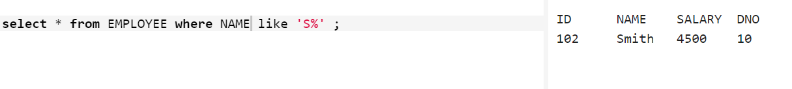

1. **List the employees whose name having exactly 5 characters.**

1. **List the employees whose name is null.**



1. **List the employees whose name is not null**

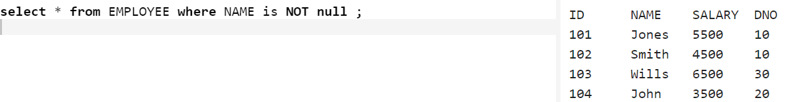

1. **Display employee count, total salary, average, min salary and max salary.**



1. **Find the sum of salaries in each dept.**
2. **Find the total employee count in each dept.**
3. **Find the min salary in each dept.**
4. **Find the max salary in each dept.**

1. **Display employee sorted by ascending order by salary**

1. **Display employee sorted by descending order by salary**

1. **List all the employees who belongs to Wills dept**

